Instructions – You can draw a network diagrams or a tables. Whichever works best for for…
- Using the following figure below, perform resource leveling. Assume that each task can be performed independently of the other task.

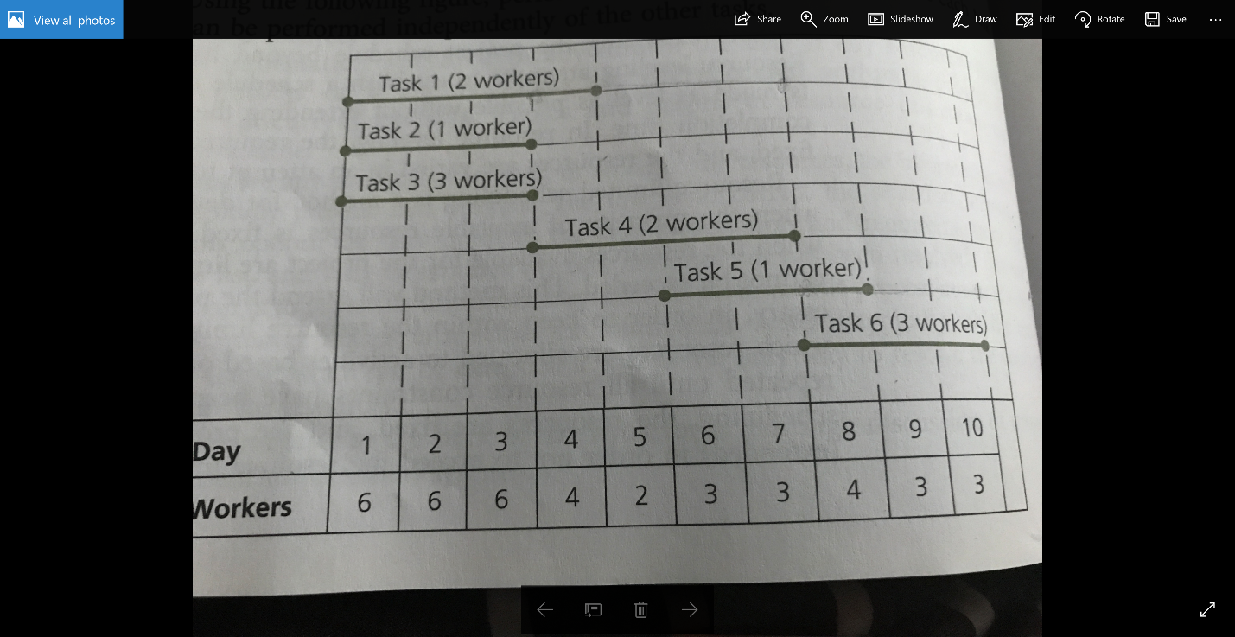
1b. Using the figure above, perform resource – limited scheduling. Assume that you have only three workers available at any given time. What is the new completion date for the project?

2a. Refer to the table below, what is the cumulative budgeted cost at the end of week 6?
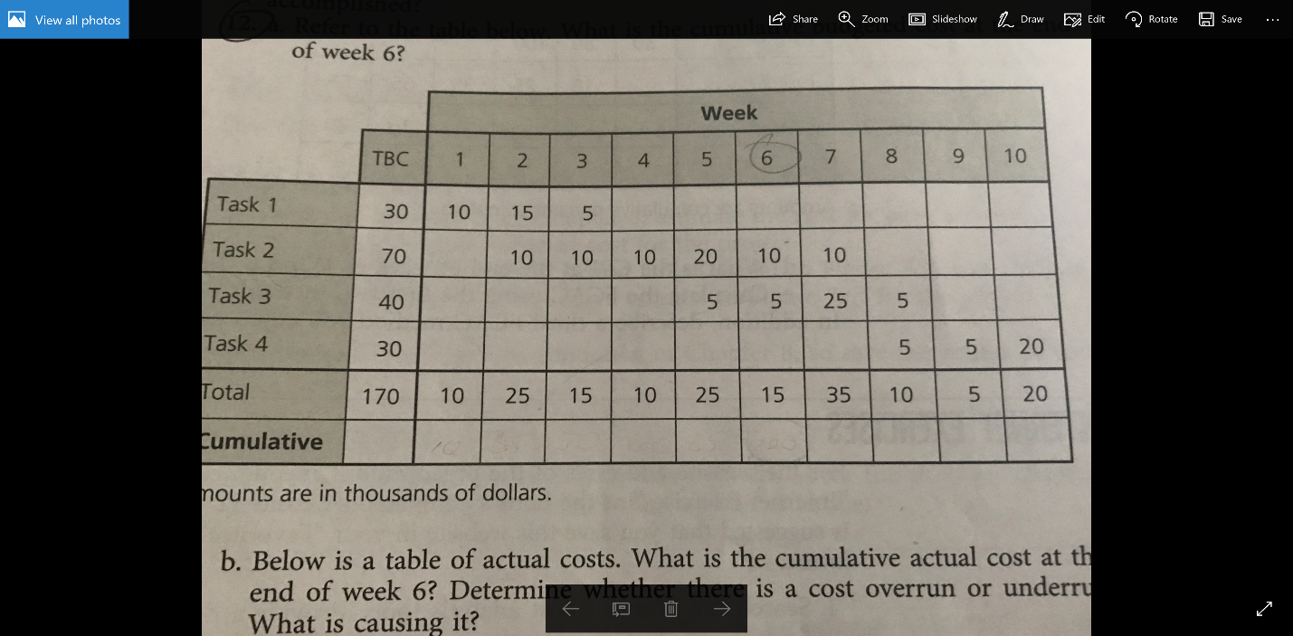

2b. Below is a table of actual costs. What is the cumulative actual cost at the end of week 6? Determine whether there is a cost overrun or underrun. What is causing it?
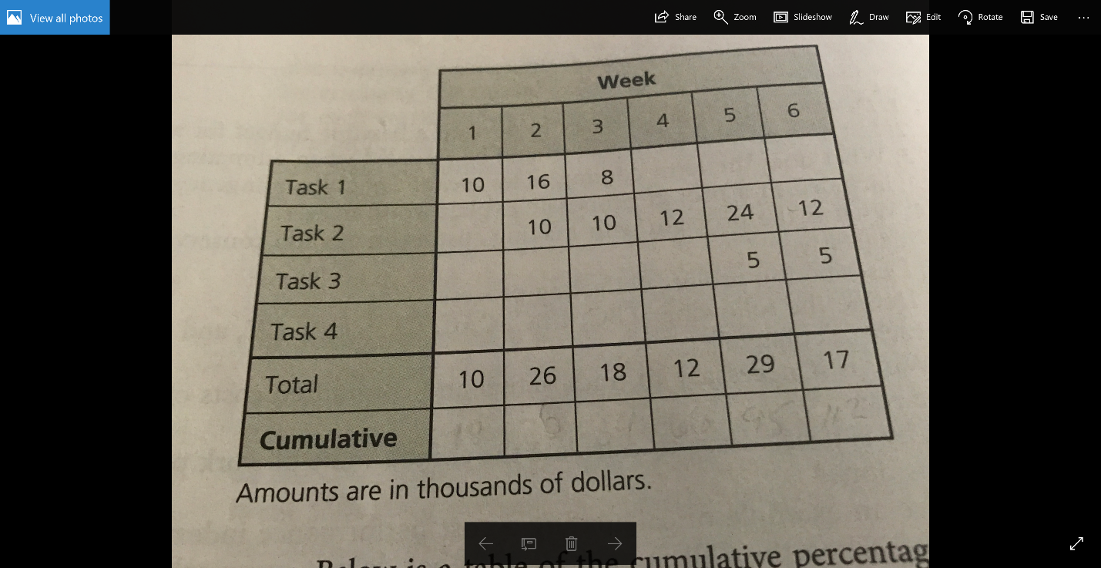

2c. Below is a table of the cumulative percentages of work completed by the end of week 6. What is the cumulative earned value of the project at the end of week 6? Is it good?
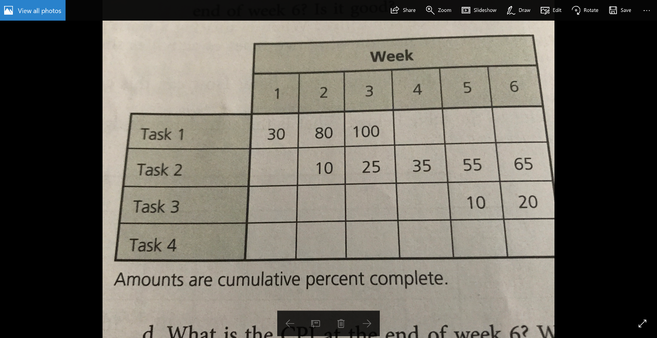
d. What is the CPI at the end of week 6? What is the CV?
e. Calculate the FCAC using the first two methods described in the chapter. In addition, describe a third FCAC method you could use.

